# SLM Create the Monthly KPI Status Report Procedure

Service Level Management

**Purpose**

The Monthly KPI Status Report.is a power point presentation that is used to summarize SLM stats for Senior Management. This report is rolled up with other Service Delivery Team reports. It is very important the stats shown in this power point agree with and support the other Service Delivery team’s stats. A meeting is held every 2 weeks with all Service Delivery Teams to provide collaboration on changes, (major) incidents, and SLM outages. The Monthly KPI Status Reportmust be published by COB on the fifth business day of the current month

**Related Policy**

* [IT Service Management Policy](https://sharepoint.jackson.com/sites/integrity/_layouts/15/WopiFrame.aspx?sourcedoc=%7be34fe42a-654a-469a-9d38-6612f00486dc%7d&action=view)

**Audience**

The following groups are responsible for adhering to this document:

* Service Level Management

**Procedure**

|  |  |
| --- | --- |
| Step | Action |
| 1 | US Capacity Planning will send an email with a link to the *KPI Summary for Jackson* power point document for the prior month. The information in this document will be used to update the SLM Monthly KPI Status Report. This email should be received by 3rd of the month and is to be filed in the email folder “Reporting: KPI”. Click on the link in the email to open the US capacity planning report: |
| 2 | Open the previous month’s *KPI Status Report* located in the folder below; this document will be updated with the new information from this month’s *KPI Summary for Jackson* document.  O:\Service Delivery\Service Level Management\Reporting\Monthly KPI Reports Power Point  **Note:** The prior year’s documents will be under that year’s folder. |
| 3 | Edit the following information on the first page. See appendix A   * Submitted by: Type in your name * Date: Type in the date that the report is being prepared.   **Note:** The Monthly KPI Status Reportmust be published by COB on the fifth business day of the current month.   * Skip the second page. This will be covered in Step 8. |
| 4 | The third and fourth pages of the *KPI Status Report* are for the Tier 1 applications. See appendix C  **Note:** The report sent by US Capacity planning (*KPI Summary Report* for Jackson) has only 1 page for Tier 1 applications; the applications run off the page.   1. On the first Tier 1 page (Page 3) of the *KPI Status Report,* right click anywhere in the table. 2. Select the “Delete Table” option. This will remove last month’s content from this page.      1. On the second Tier 1 page (Page 4) of the *KPI Status Report*, right click on anywhere in the table. 2. Select the “Delete Table” option. This will remove last month’s content from this page. 3. Copy the table from the second slide (Tier 1 applications) from the *KPI Summary Report* for Jackson and paste it (using the second paste option “Paste Keeping Source Format”) into the 3rd and 4th pages of the *KPI Status Report.*      1. On the first Tier 1 page (Page 3) of the *KPI Status Report,* highlight and cut the part of the Tier 1 applications information that does not fit on the page. 2. On the second Tier 1 page (Page 4) of the *KPI Status Report*, after the Application / Date bar, highlight and cut the part of the Tier 1 applications information that was left on Tier 1 first page (Page 3).   Verify the percentages in the previous month’s column against the Monthly SLA report. Sometimes the numbers on the KPI report will need to be rounded up or down.  **Note:** It is very important all this month’s KPI totals published information MUST match the information published in this month’s SLA report.   1. Center and align the tables so they fit the page. 2. Print off the *KPI Status Report* that was created in the previous month. 3. Ensure that the percentages for all the previous 12 months match what is on the current report being created. If any numbers were rounded up, the percentages could have changed, causing the cells to go red and reporting an incorrect SLA. If this is the case, update the cell to match what it was the previous month.   **Note:** It is very important all previous month’s published information MUST match the information published in this month’s report.   1. If any new applications have been added to the KPI report, data will not appear in all of the cells on the report. The cells should be merged and these blank cells should be colored gray. A comment should be entered in those cells indicating this is a new SLA. |
| 5 | The fifth page of the *KPI Status Report* is for Tier 2 applications. See appendix D   1. Repeat the process used for Tier 1 applications in step 4. |
| 6 | The sixth page of the *KPI Status Report* is for Infrascrture applications and Report/File Deliveries. See appendix E   1. For each section repeat the process used for Tier 1 applications in step 4. |
| 7 | The seventh page of the *KPI Status Report* is for OLA Breached Tickets. See appendix F   1. Print off the Summary page of the *Monthly OLA Breached Report* for the previous month at:   O:\Service Delivery\Service Level Management\Reporting\Monthly OLA Breached Report  **Note:** The monthly report is also posted on Sharepoint in this location:  Report Storage > Monthly Reporting > SLM > Monthly Production OLA Breached Report > YYYY   1. Update the monthly values and the 13 Month total values:    1. Cut the oldest month column (example Dec 2016).    2. Insert a row between the last month and the 13-month total column.    3. Paste the cut data into this row.    4. Rename the header to the new month (example would Jan 2018).    5. Subtract each row’s numbers in the new column from the 13-month totals. (145,581-10751 example for Total Incident Tickets PGDS row).    6. Clear the values from the new column and using the data from the Monthly OLA Breached Report, ALL BREACHED OLA SUMMARY (page 2), manually fill in the data for the previous month.  |  |  |  |  |  |  |  |  |  |  |  |  |  |  |  | | --- | --- | --- | --- | --- | --- | --- | --- | --- | --- | --- | --- | --- | --- | --- | |  | Dec 2016 | Jan 2017 | Feb 2017 | Mar 2017 | Apr 2017 | May 2017 | Jun 2017 | Jul 2017 | Aug 2017 | Sept 2017 | Oct 2017 | Nov 2017 | Dec 2017 | 13 Month Total | | Total Incident Tickets PGDS | 6678 | 8751 | 8369 | 9984 | 8765 | 12999 | 14094 | 18636 | 11706 | 9248 | 12196 | 13404 | 10751 | 145,581 |  1. Add the new column’s number for each row to the corresponding 13 Month Total cell to produce new 13 Month Totals. 2. Calculate the percentage for the “% Breached Tickets” row for the new column and the % Breached Tickets for the 13-month column by using the data in the cells in the new column using the following formula:   **Total Breached Tickets / Total Incident Tickets PGDS Total X 100%** |
| 8 | Update the second page with SLA and OLA summary information. See appendix B   1. If any of the SLAs are in red for the month, add the details of the Missed SLA from the Monthly SLA Report to the second page. This should include:  * The Service Target / Metrics information * Any days in which the SLA was missed during the previous month, complete with comments.   ***Example:*** Service Level Agreement KPI  ***Commissions Checks Fin.*** *Target : 98.00% Mon-Fri 11:00*  *04-04-2017, Tue 0.00% INC1220979 Month / Quarter End*  *processing.*   1. Add a new slide for each breached SLA starting at Slide 3. Use the information from the incident tickets to explain in detail what the error, impact, and resolution were. 2. If no SLAs were breached, add the following comment to the “Service Level Agreement KPI” section:   *No KPI SLAs were breached.*   1. Add a comment regarding the Breached OLAs, using the information from Page 7 of the KPI report.   ***Example:***   * Operational Level Agreement KPI   + OLA Breached Incidents 7.63% - There was a total of 8,765 JTS tickets with service target OLAs and 669 of those were breached.  1. Add any pertinent comments regarding SLAs / OLAs.   ***Example:***   * Additional Information   + Finalizing SLA Contract for Jackson Operations – adding eFeeds and updating stale content. |
| 9 | Post the KPI Report to [Sharepoint](http://docs.jackson.local/it/sites/rs/_layouts/15/start.aspx#/Monthly%20Reporting/Forms/current.aspx?RootFolder=%2Fit%2Fsites%2Frs%2FMonthly%20Reporting%2FSLM%2FMonthly%20KPI%20Report&FolderCTID=0x0120008757BF0A693734429A00C5DB64BC5778&View=%7B240B9B17%2D0630%2D4691%2DAA51%2DE27EC38CF00E%7D) in the appropriate “Year” folder.  A link to the report will be sent within the final Monthly SLA Report email on the seventh business day of the month.  See ***SLM The Monthly SLA Report Procedure*** for more information. |

**Appendix A – First Page Example**

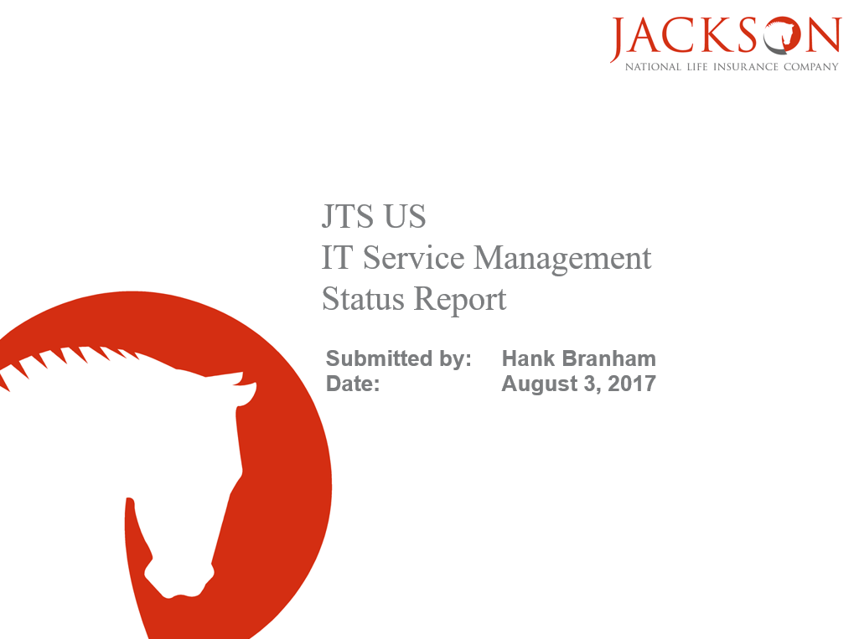

**Appendix B – Second Page Example**

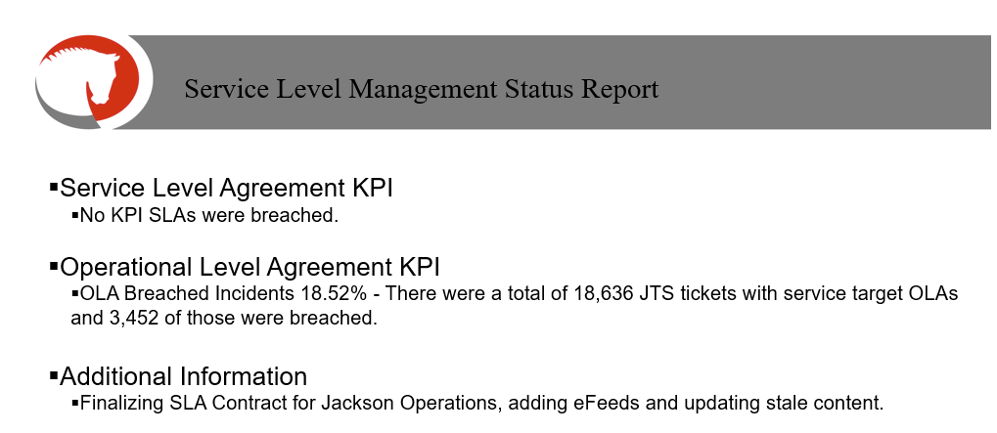

**Appendix C – Third & Fourth Page (Tier 1) Examples**

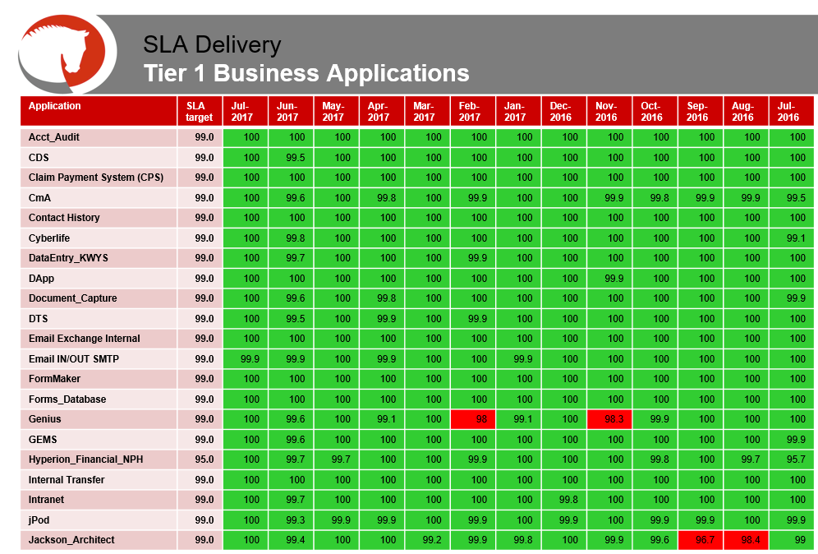

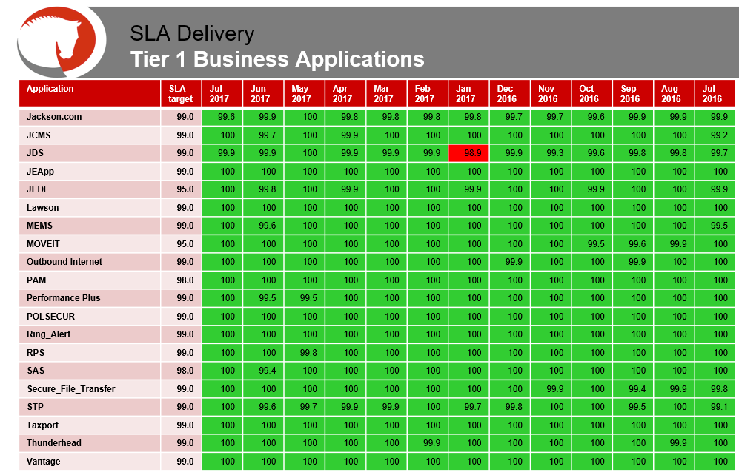

**Appendix D – Fifth Page (Tier 2) Example**

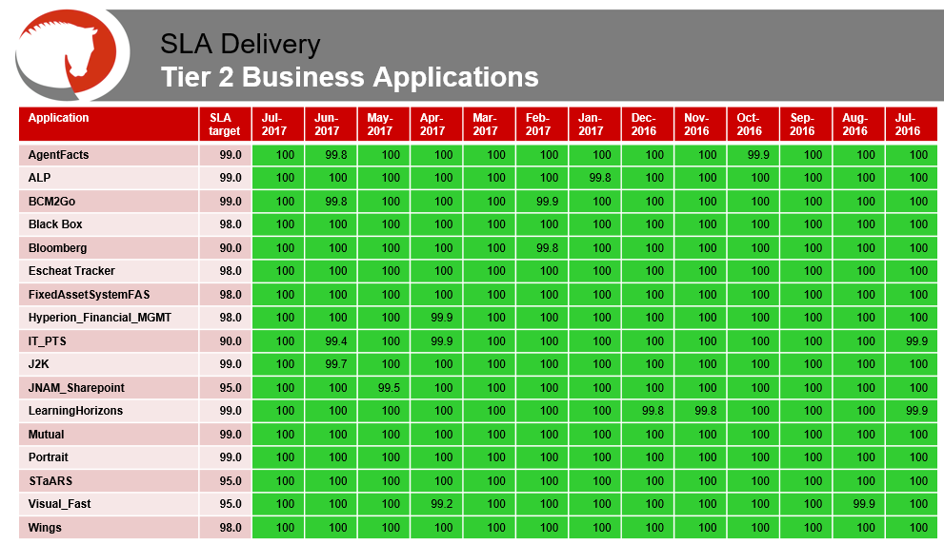

**Appendix E – Sixth Page (Infrastructure / Report & Deliveries) Example**

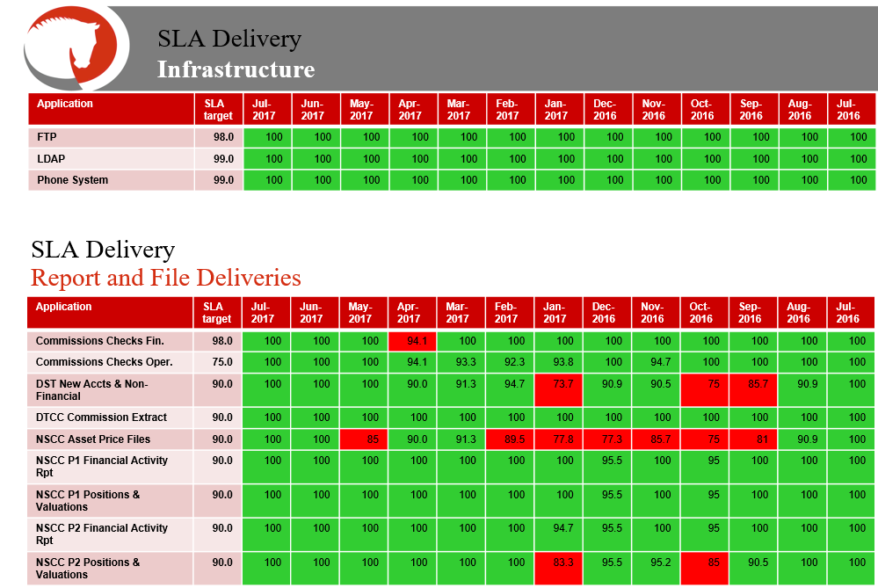

**Appendix F – Seventh Page (Breached Tickets)**

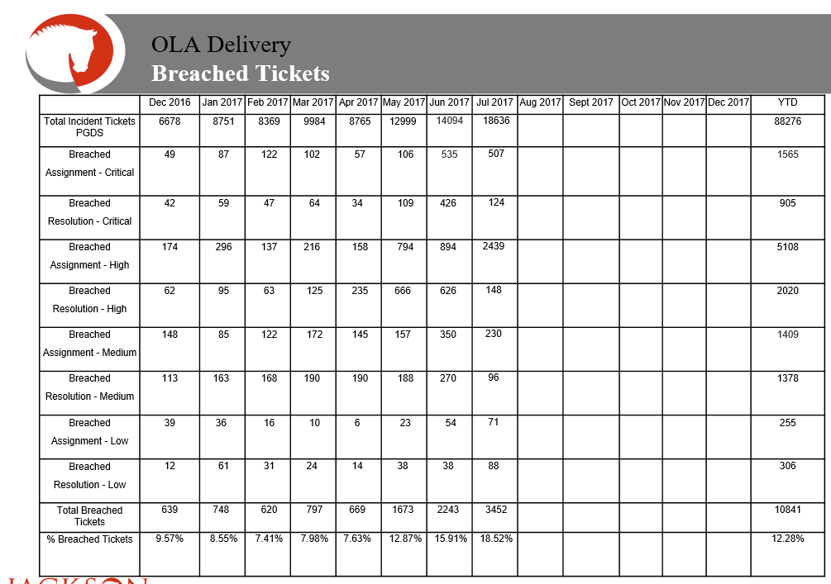

**Modification**

The following associates can make modifications to this document:

* Manager, Service Level Management
* Director, IT Service Management
* Vice President, Service Delivery
* Chief Technology Officer, PGDS

|  |  |
| --- | --- |
| Service Level Management Process | |
| Responsible Party: Anna Carter, Manager, Service Level Management Approving Authority: Abdul Golden, Director, IT Service Management | Date Created: 08/08/2017 Last Modified:  Last Reviewed: |